**EXPERIMENT 9**

**AIM**

Experiment to study Filters and software management commands.

(head, tail, sort, nl, wc ,cut, sed ,uniq ,grep,apt-get ,tar etc.)

a) Use a pipeline and command substitution to find number of lines and

character within file.

b) Write a program using sed command to print duplicated lines of Input

c) Write a grep/egrep script to find the number of words character, words and

lines in a file.

d) Write an egrep script to display list of files in the directory.

$nl :The nl command reads the File parameter (standard input by default), numbers the lines in the input, and writes the numbered lines to standard output. In the output, the nl command numbers the lines on the left according to the flags you specify on the command line.

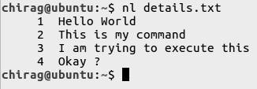

$cut :The cut command in UNIX is a command line utility for cutting sections from each line of files and writing the result to standard output. It can be used to cut parts of a line by byte position, character and delimiter. It can also be used to cut data from file formats like CSV.

1. **$cut -b : $cut -b** is used to cut specific number of bytes from a file and then display it.

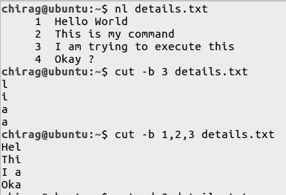

1. **$cut -d :** Instead of selecting x number of characters, if you like to extract a whole field, you can combine option -f and -d. The option -f specifies which field you want to extract, and the option -d specifies what is the field delimiter that is used in the input file.

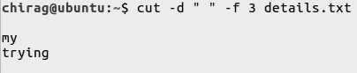

Head tail sort wc

Cut

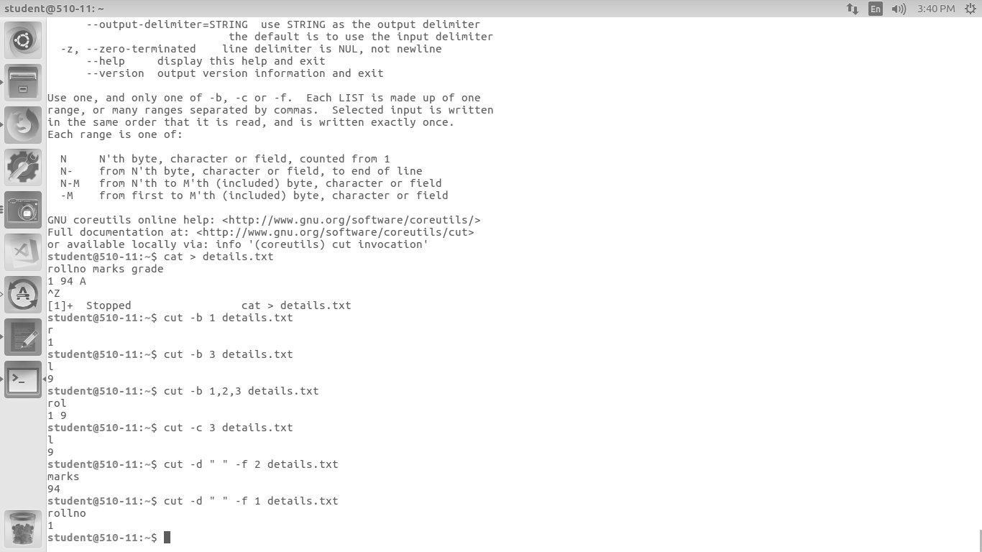

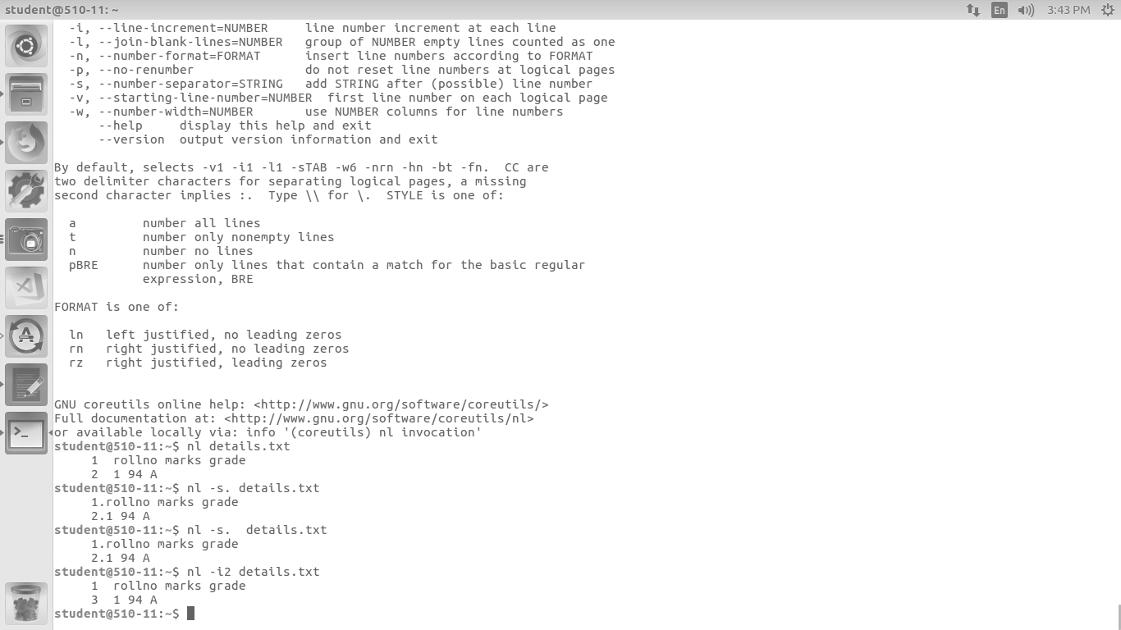

grep: global regular expression print

C count

l filename

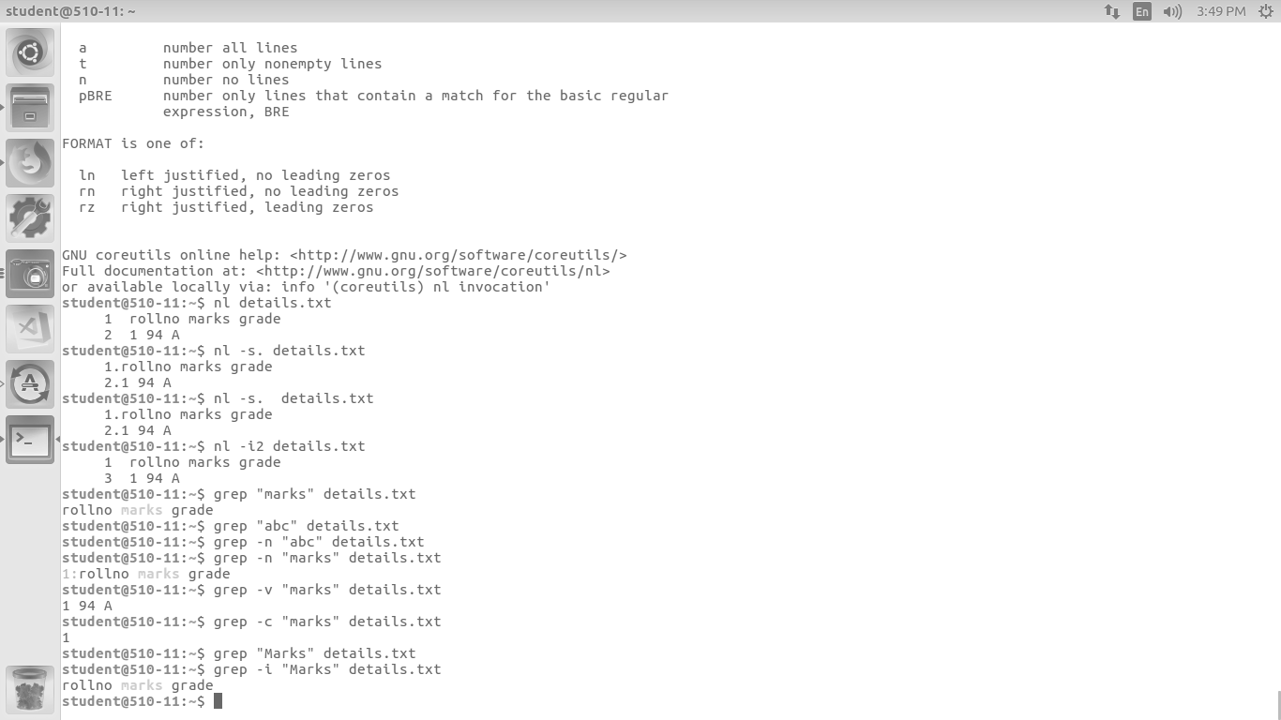

* zero or more characters

? exactly 1

+ 1 or more

Special characters:(egrep)

$ ends with char

^ beginning with char

+ one or more char

* zero or more char

[ ] range

. one char

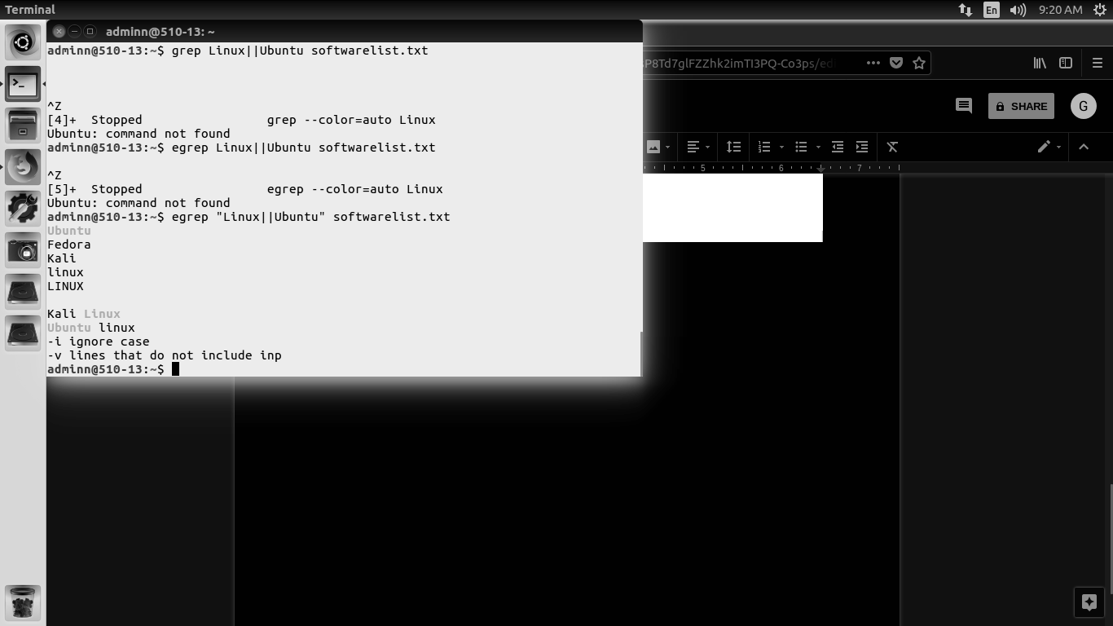

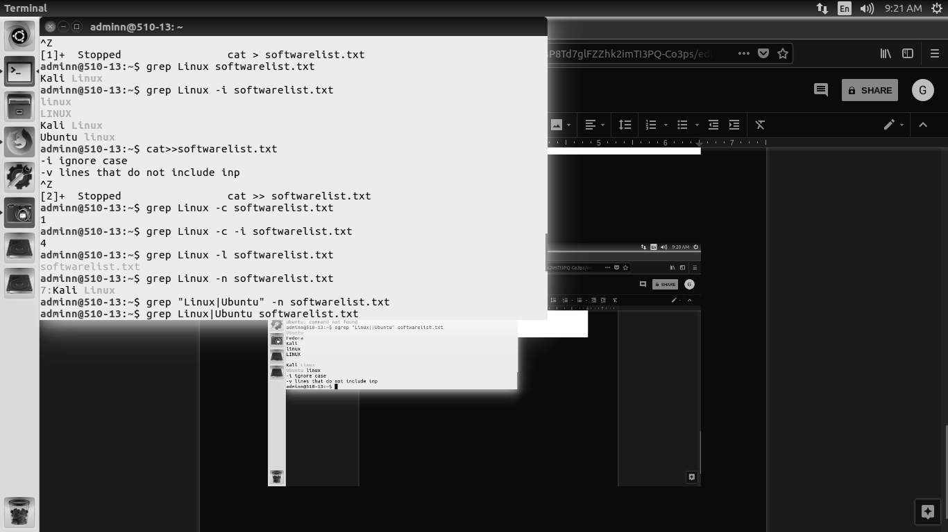

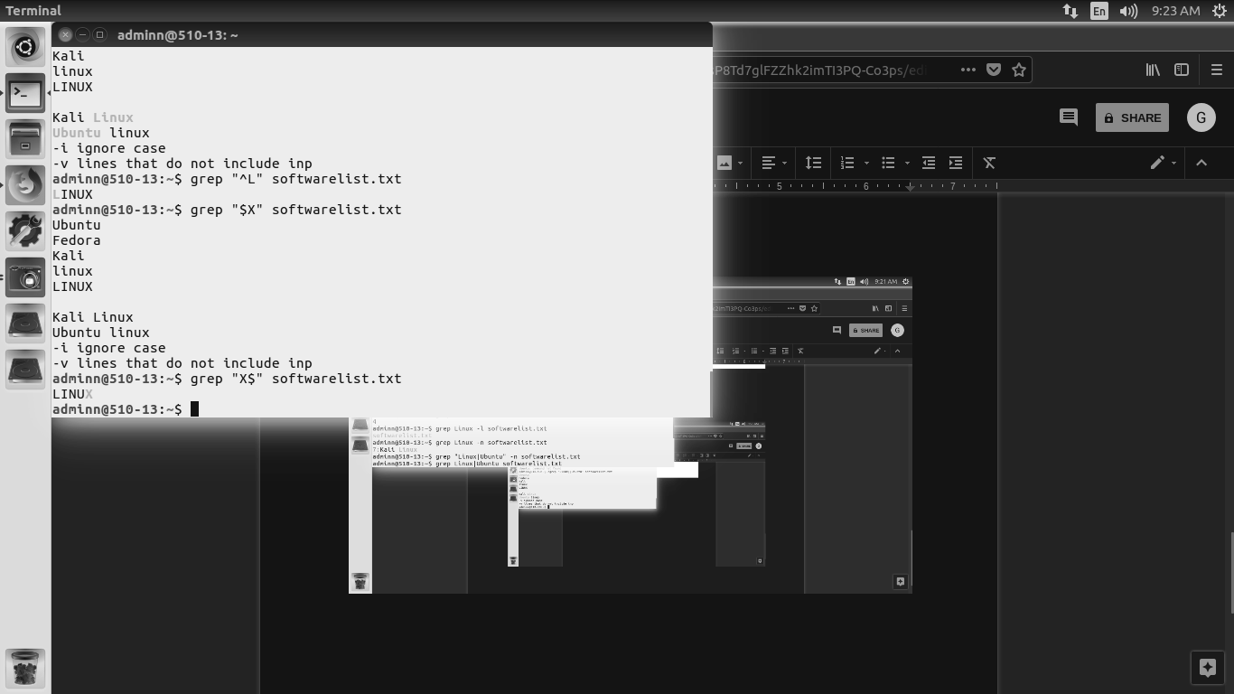

Sed

sed ‘s/string to be replaced/replacing string/’ filename

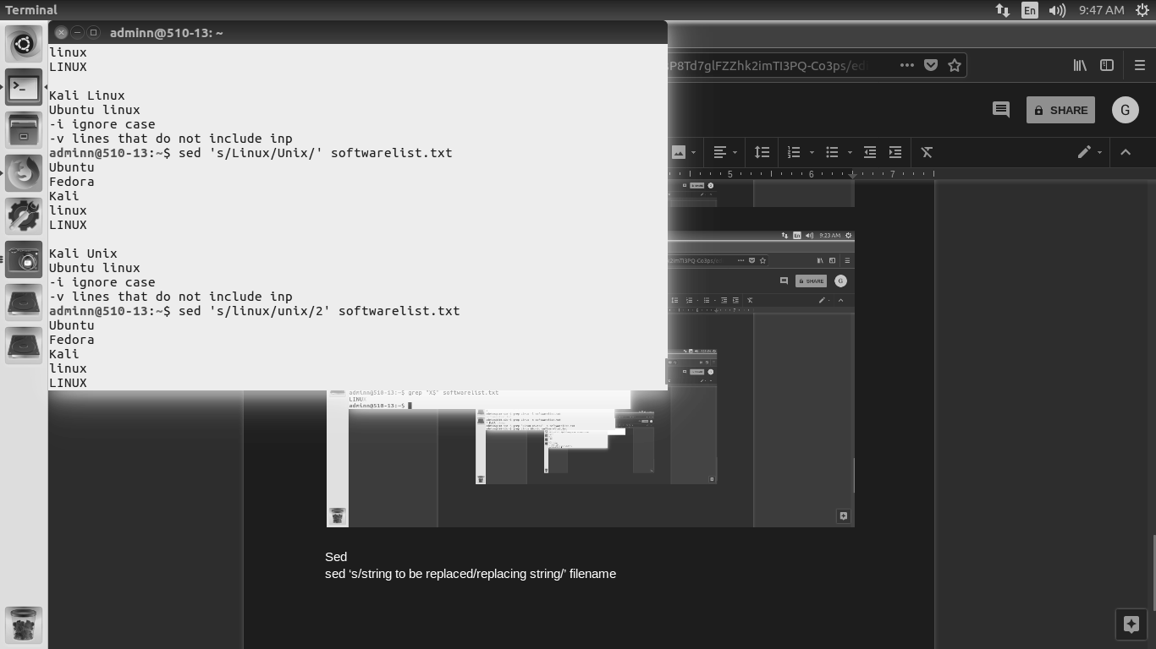

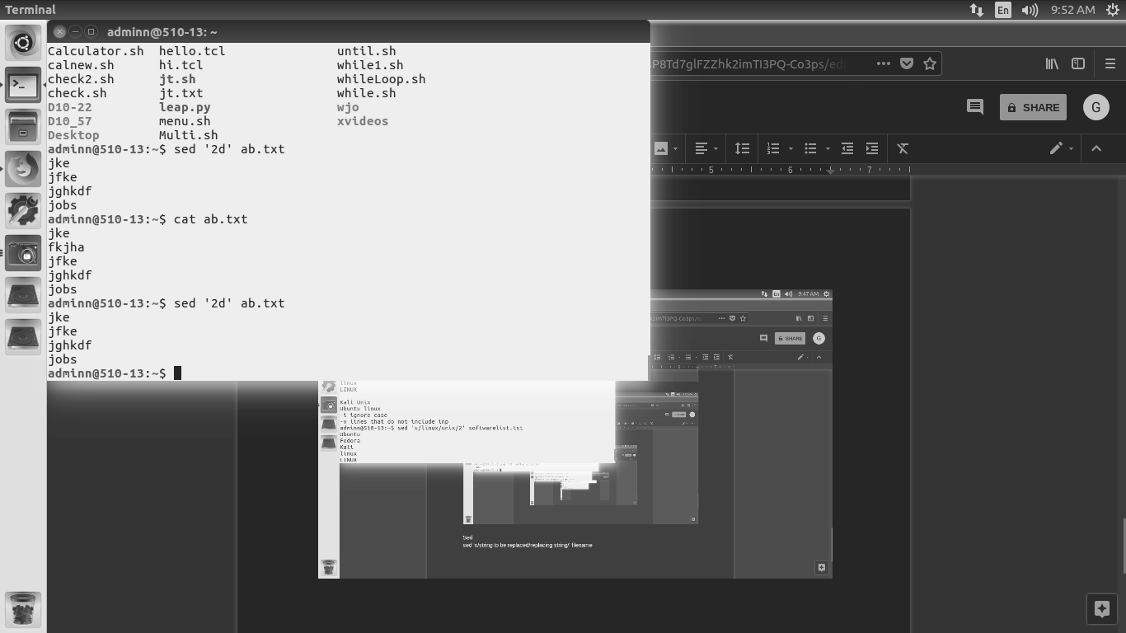

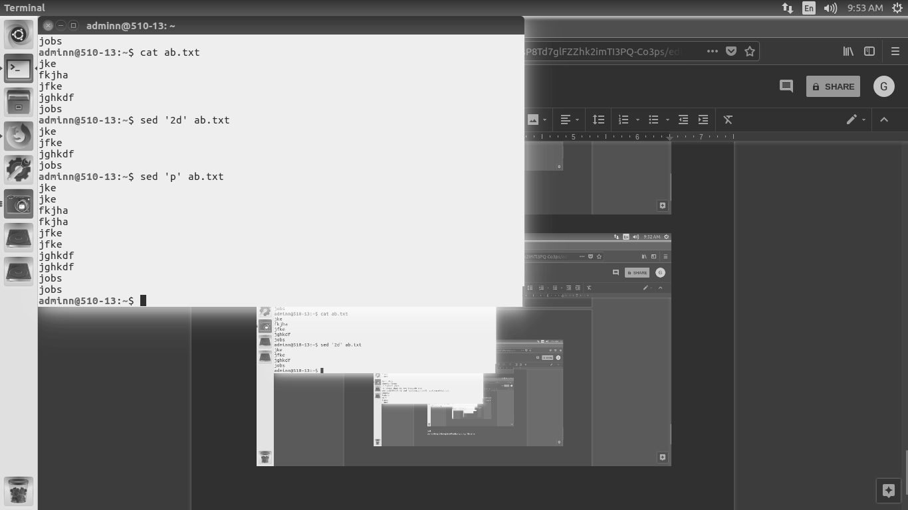

CONCLUSION

Filters and software management commands have been studied executed.